tAggregratedSortedRow

With this function we aggregate the already sorted input data, based on a set of operations for the desired output. We can customize the output in columns as required and the output obtained is the better aggregated data of the input.

STEPS:

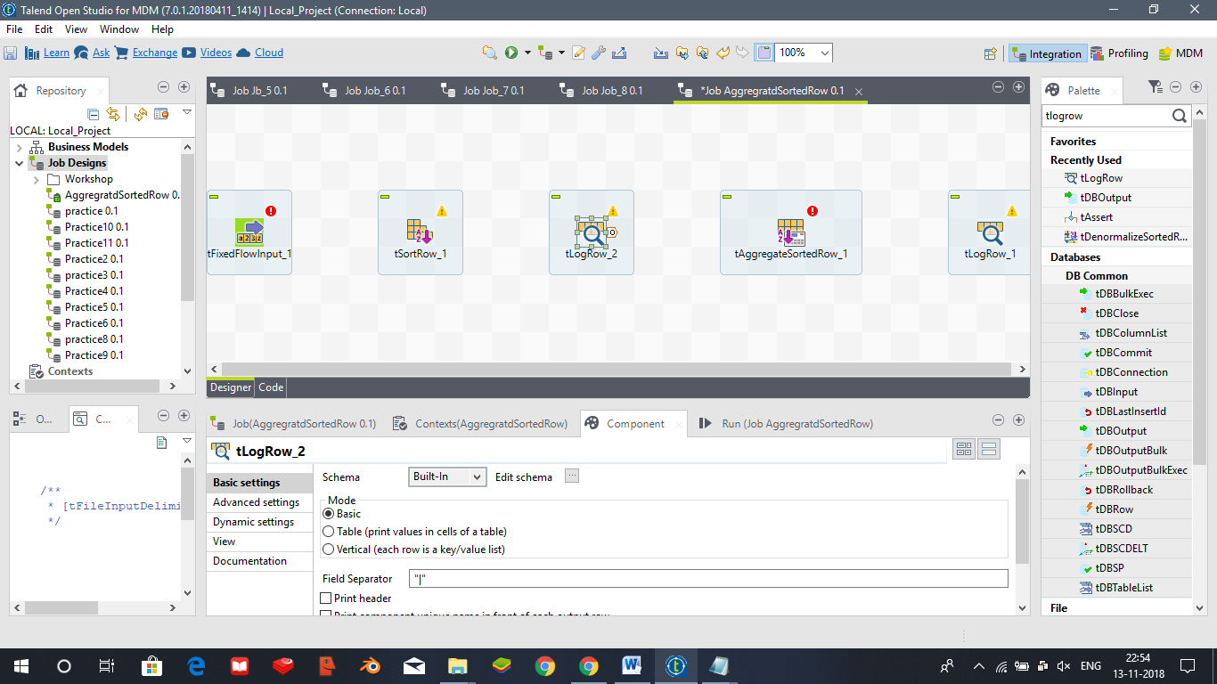

Get the components: tFixedFlowInput, tSortRow, tAggregatedSortedRow, tLogRow. And connect them in the following order.

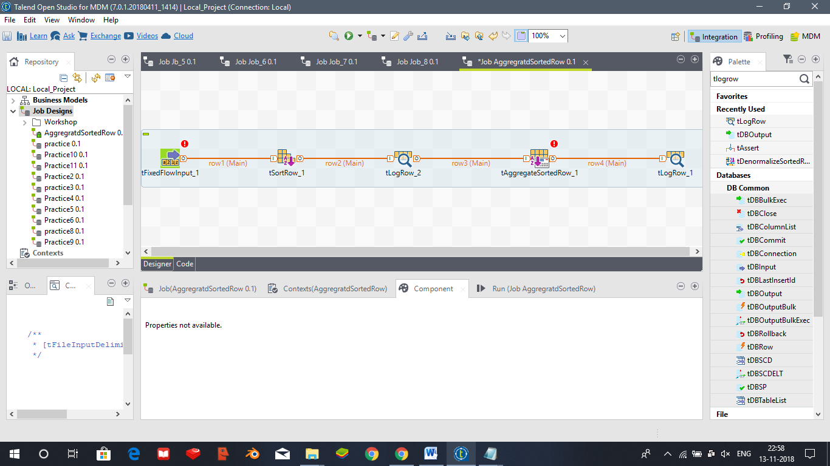

Now we configure tFixedFlowInput by selecting Mode as Use Inline Content (delimited file) like this and entering the required data.

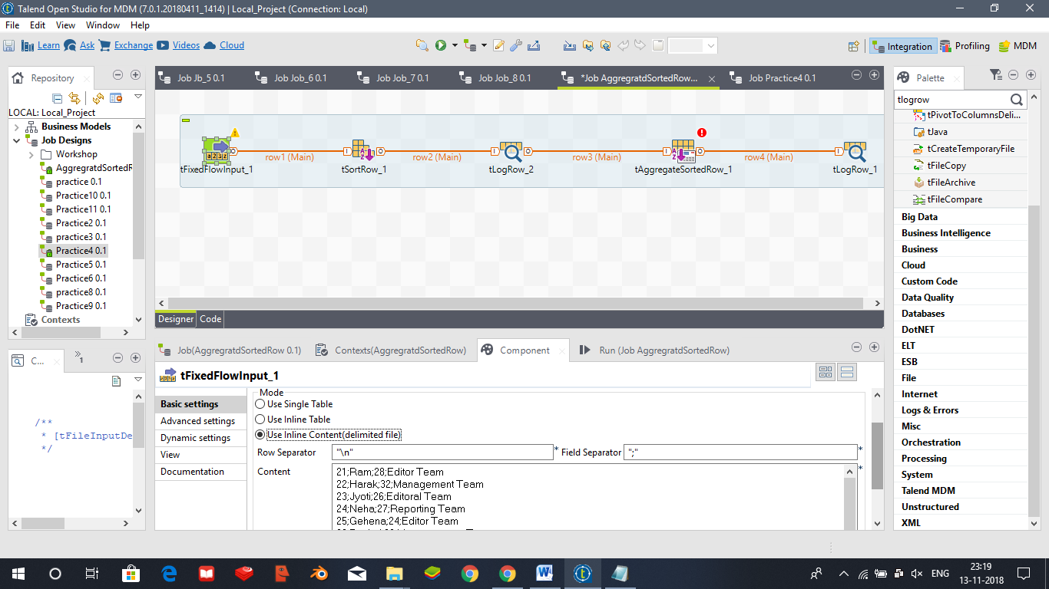

Then we edit the schema like this

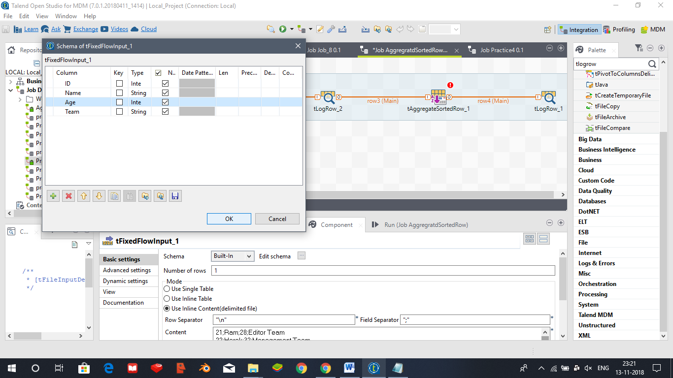

And propagate the changes.

Now we configure the tSortRow component and we add the criteria with which we want to sort the data accordingly.

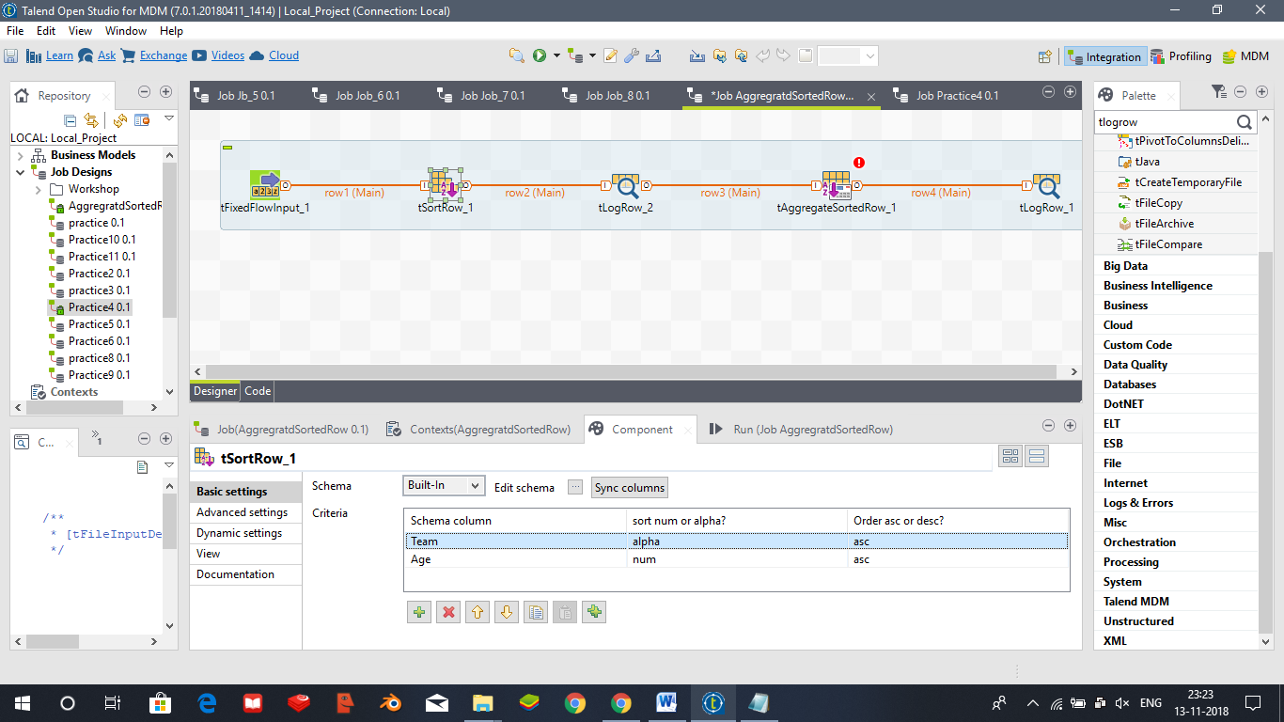

tAggregatedSortedRows schema is edited as

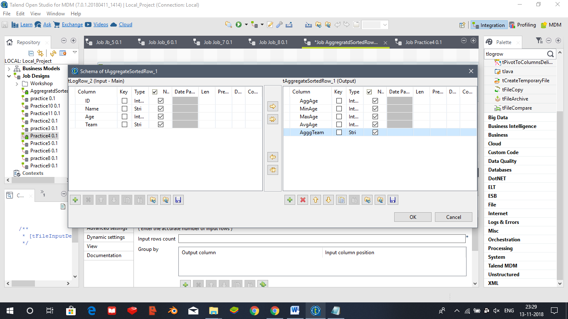

And click ok to propagate the changes. We can group by accordingly and operations as follows

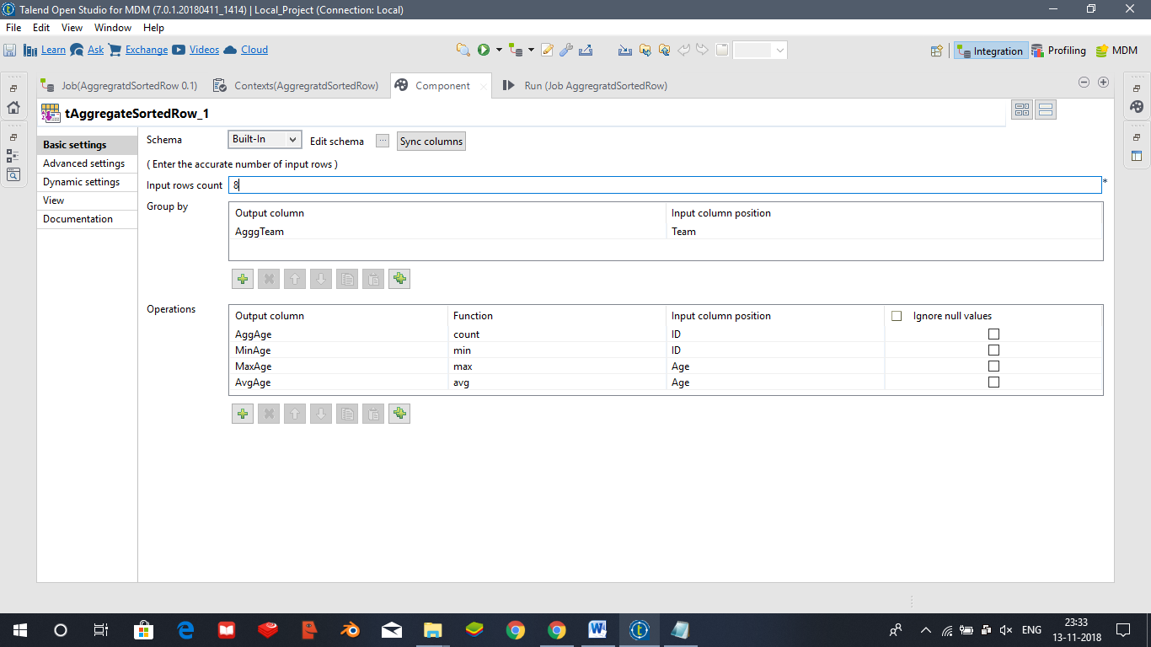

And we finally configure the tLogRow component as

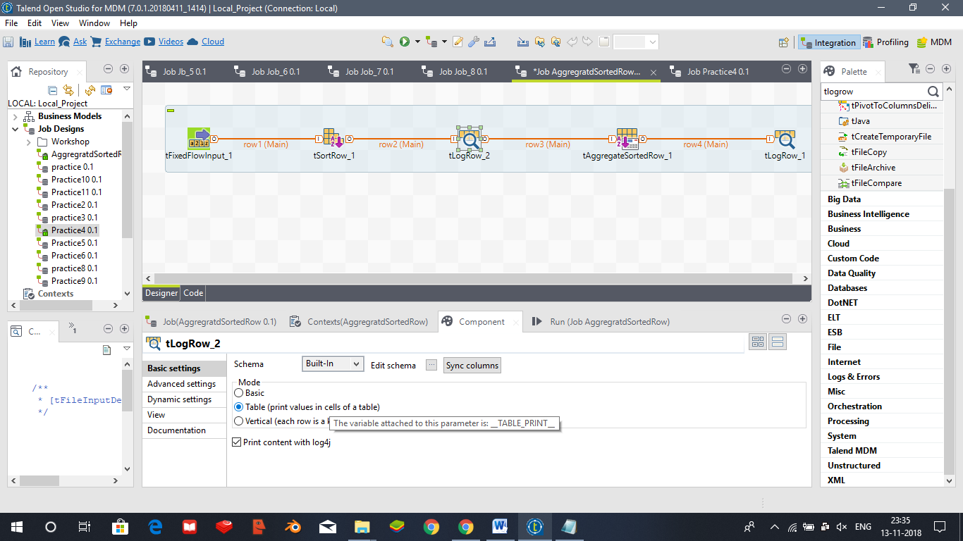

The output we get is as follows as after saving and executing as

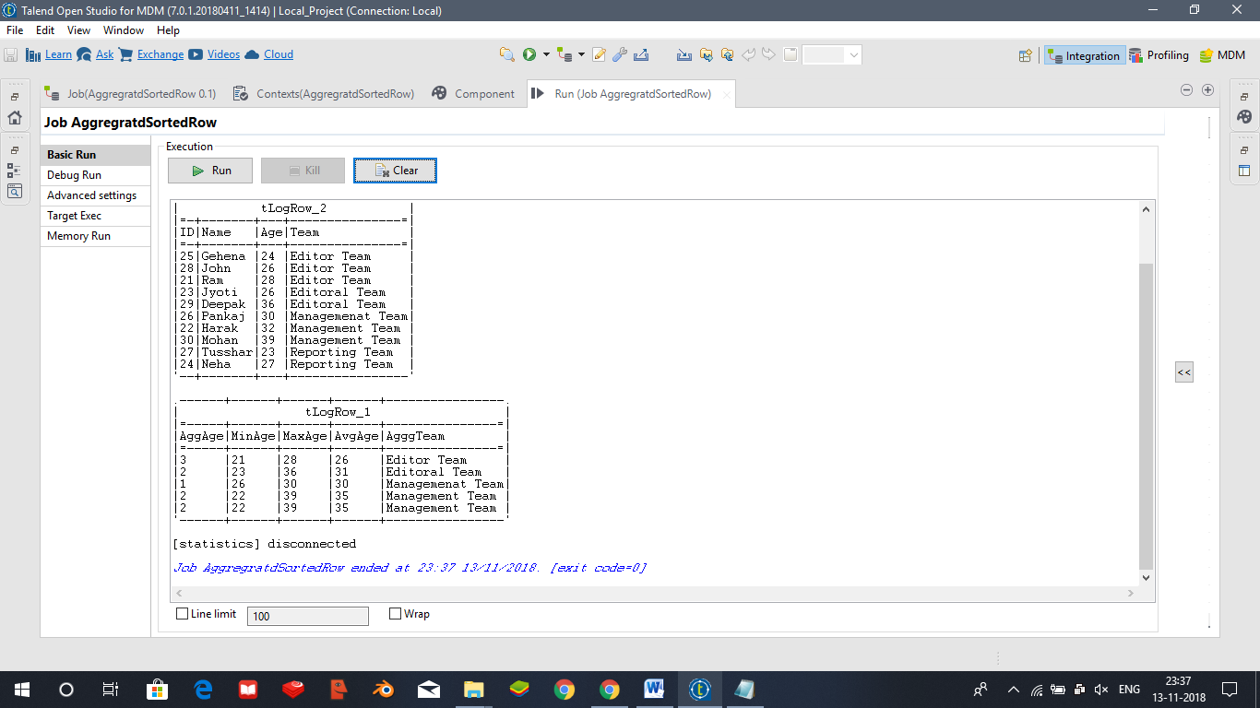

tDenormalize

In computing, **denormalization** is the process of trying to improve the read performance of a database, at the expense of losing some write performance, by adding redundant copies of data or by grouping data.

We add the following components: tInputDelimited, tDenormalize, tLogRow.

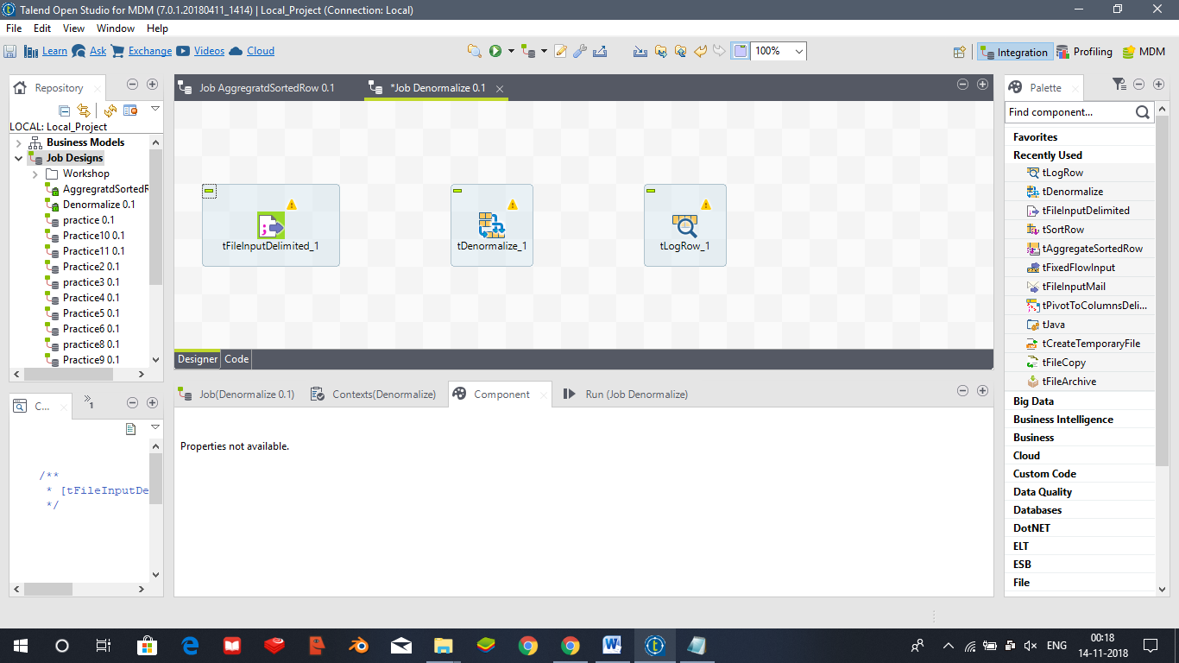

And connect them using Row->Main.

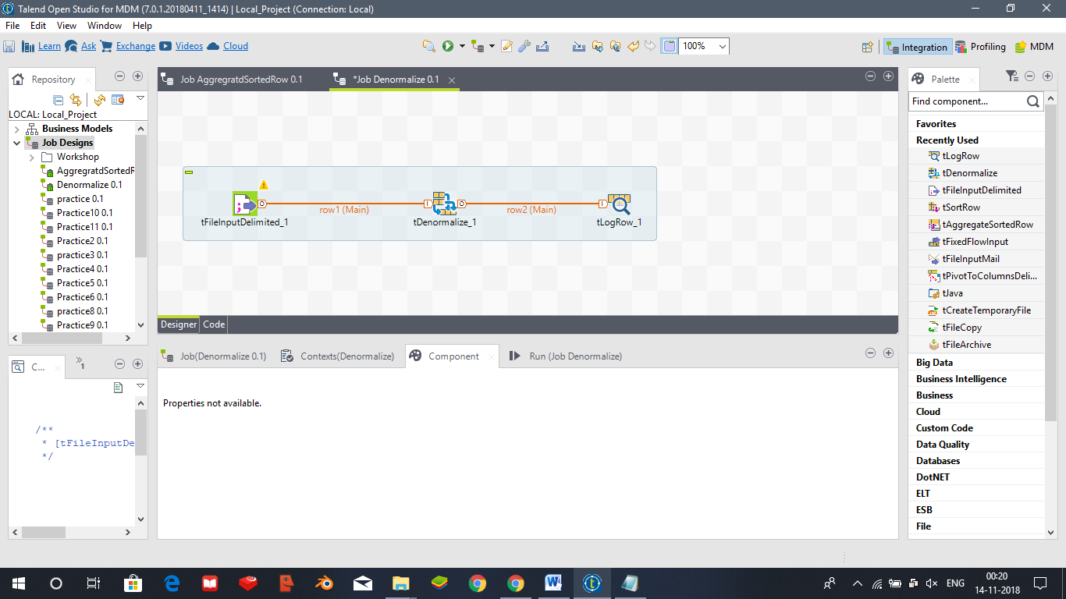

Configure the tFileInputDelimited and add the required data file.

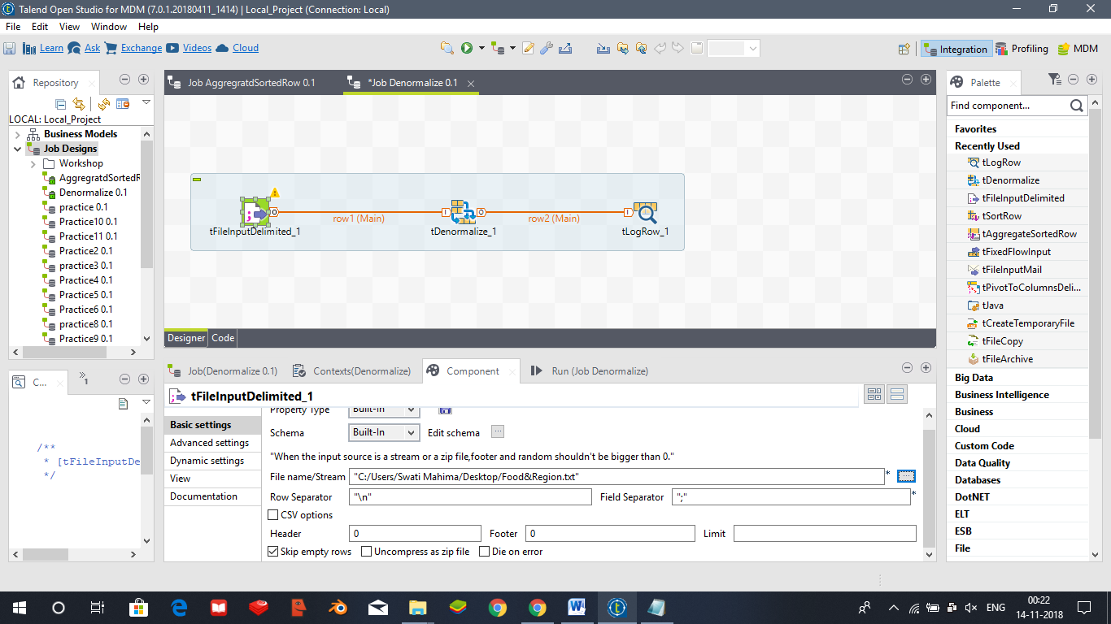

And edit schema as follows

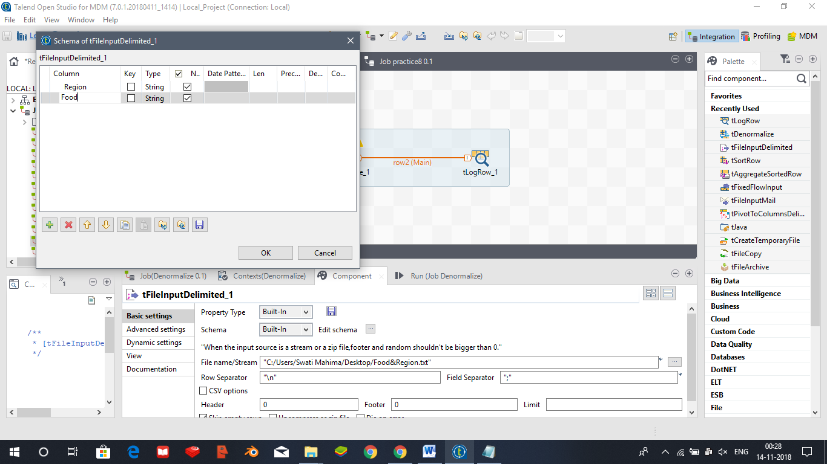

we configure the tDenormalize component as follows

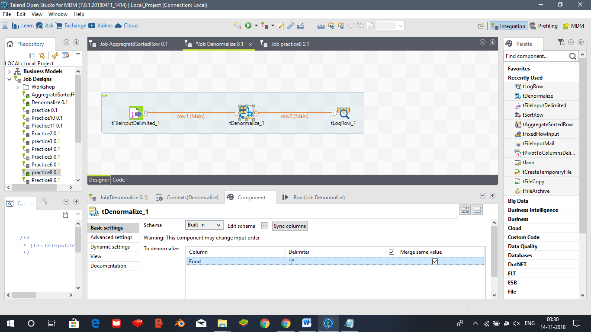

Similarly tLogRow component

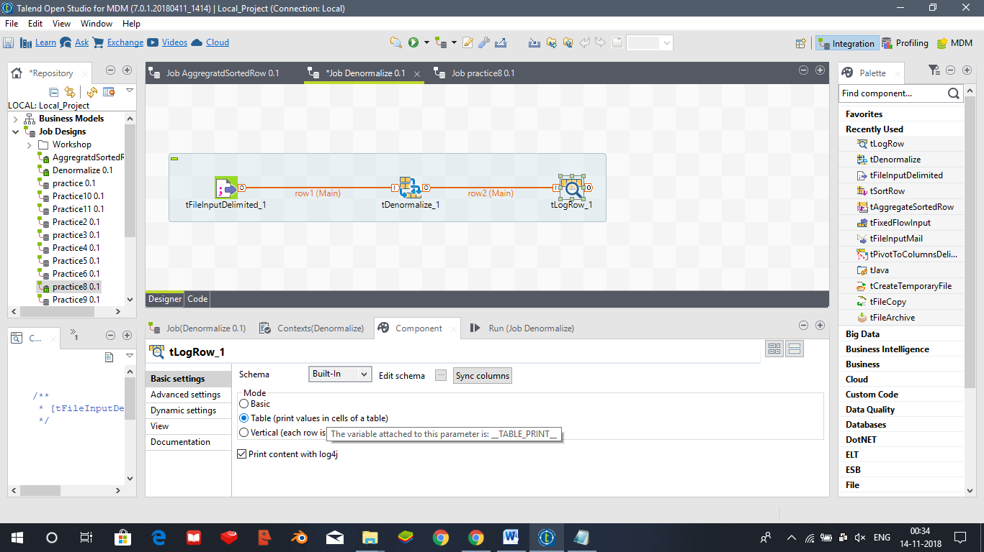

Now we save and execute the job and obtain the following result

